Study Group 1.1 - Information Pack (Greece)

How has Greece itself been affected by integration into the EU?
-How has Greece's GDP been affected?
In the wake of the Eurozone crisis, it's important to consider how integration with the EU has affected countries such as Greece. Greece joined the EU in 1981, adopting the Euro in 2001. Greece’s GDP and its patterns post-integration are important as an indicator, however it's imperative that we also estimate their potential GDP per capita without integration. This synthetic control method estimates the effect of integration by comparing the evolution of an aggregate outcome variable for a country affected by integration.
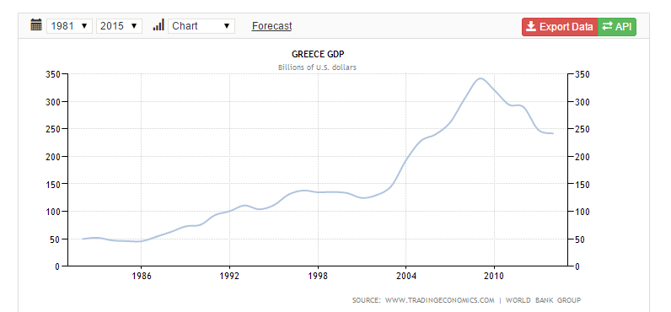
Graph showing GDP growtg in Greece after integration (1981-Present).

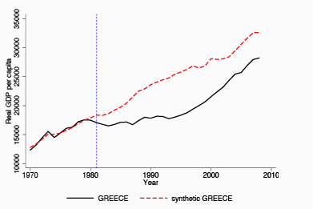
Greece's actual and synthetic real per capita GDP in the 1980s.
The results suggest that GDP per capita would have been higher had Greece not joined the EU. However, from 1981 to 1995, growth rates in the EU were relatively higher, and Greece experienced divergence. Until the Eurozone crisis, integration delayed a broad range of structural reforms in Greece.

-How have Greece's economic policies changed?
Greece’s government deficit as a share of GDP reached double-digits by the late 1980s, before fiscal consolidation brought it down to almost 1% of GDP in 2002. Greece joined the EU with a government debt to GDP ratio of 25%, which reached 109% by the mid-1990s. Public sector debt remains above 100% of GDP, despite recent progress in fiscal consolidation. Greece had high inflation before joining the EU: average annual inflation was 20% during the late 1980s and early 1990s. However, macroeconomic stabilisation brought inflation down to 2.6% in 1999: inflation is currently about 1.5 percentage points above the euro area average. Although fiscal consolidation and policies to bring down inflation often lead to slower growth in the short term, this isn't true for Greece: growth in Greece accelerated after the fiscal consolidation. Simultaneously, efforts to address fiscal imbalances led to falling inflation rates, despite considerably lower interest rates.

-How has its unemployment been affected and what changes can be observed in inward and outward migration?
The jobless rate in Greece reached a record high of 28% in November, even more striking for those under the age of 25, unemployment hit 61.4%. A reduction of jobs available, especially for youth employment, has caused a population declined by 5.5% - or by 60,500 people – in 2012, from 11,123,000 to 11,062,500. Another reason for such high emigration figures is the increase in higher tax rate level to 42pc on annual incomes of €42,000 or more, in contrast neighbouring Albania and Bulgaria have a maximum 10% tax rate, so those earning a high salary in Greece are likely to move to Bulgaria or Albania.
Greece’s options for solving these problems were much more limited than if it still used its old currency, the drachma. By belonging to the Eurozone, Greece no longer controlled its own monetary policy. For instance, Greece could not just print more money to pay for its debts, since it no longer controlled the printing presses. Nor could Greece just devalue its currency to make its debt cheaper for itself. Devaluing the currency would mean that it would take fewer euros to pay for its debt in dollars. Again, this power belongs to the European Central Bank, not Greece.
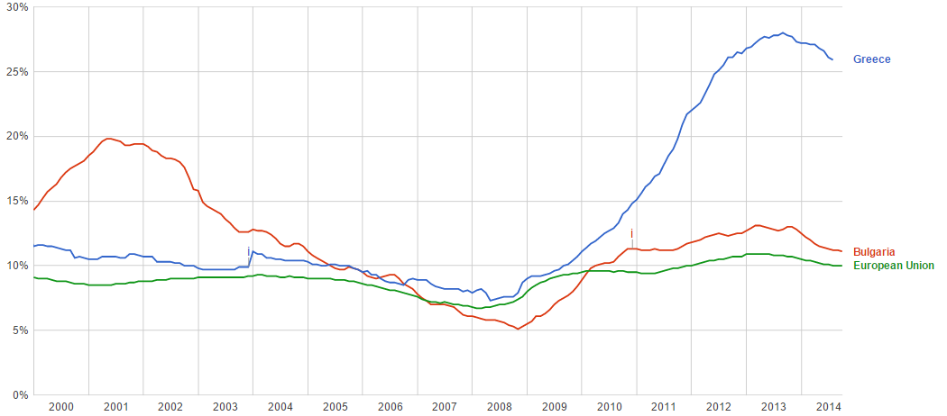
When Greece joined the EU
The graph above shows the pre-accession unemployment rate for Greece of 8%, since then it has rose to 28%, about 16% higher than the EU average, and 15% higher than its neighbouring country Bulgaria.
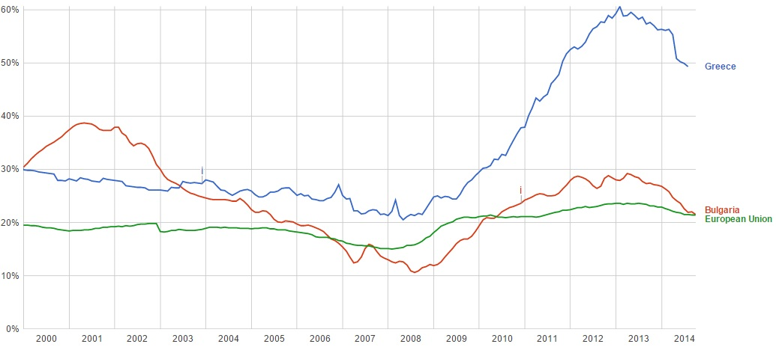
The above graph shows the huge unemployment rate in Greece for under 25’s.
An increase in unemployment leads to a vicious circle, as so tax revenues will decrease, so the government has less revenue to spend on trying to combat unemployment. Meaning unemployment increases so people move out of the Greece in search of work.

How has Greece's integration into the EU impacted on the other member states and the EU as a whole?
-What financial aid has Greece been given during its time in the EU?
Greece has continued to struggle significantly since its admission into the EU in 1981, in part due to the corruption of its governments and consequent invalid (and falsified) economic figures, which ultimately was the only reason it managed to meet the EU's convergence criteria. It has therefore been the case that, especially in more recent times, Greece has received a substantial amount of financial aid in the hope of facilitating fiscal stability and to help keep its economy afloat. In 2010 the euro area Member States and the International Monetary Fund (IMF) initiated the first Economic Adjustment Programme for Greece, with loans gathered by the European Commission's so-called "Greek Loan Facility" agreeing to supply Greece with €77.3 billion, spread over the period May 2010 to June 2013. A second Economic Adjustment programme between March 2012 and August 2014, funded by the European Financial Stability Facility (EFSF) and IMF then paid further disbursement fees in excess of €76.28 billion.

Disbursement | Date | EFSF (€billion) | IMF (€billion) | Total (€billion)
1 | March-June 2012 | 74 | 1.6 | 75.6
2.1 | December 2012 | 34.3 | - | 34.3
2.2 | January 2013 | 7.2 | - | 7.2
2.3 | January 2013 | 2.0 | 3.24 | 5.24
2.4 | February 2013 | 2.8 | - | 2.8
2.5 | May 2013 | 2.8 | - | 2.8
3.1 | May 2013 | 4.2 | 1.74 | 5.94
3.2 | June 2013 | 3.3 | - | 3.3
4.1 | July 2013 | 2.5 | 1.8 | 4.3
4.2 | December 2013 | 0.5 | - | 0.5
5.1 | April 2014 | 6.3 | 3.6 | 9.9
5.1 | July 2014 | 1.0 | - | 1.0
5.2 | August 2014 | 1.0 | - | 1.0
Second Programme Disbursement figures. From European Commission: (http://ec.europa.eu/economy_finance/assistance_eu_ms/greek_loan_facility/index_en.htm).
-How has Greece's integration/admission divided opinion amongst the other member states?
Greece has needed and continues to need substantial support from its fellow Member States, which has made its inclusion in the EU a topic of strong debate. A country exiting the EU completely would be quite a difficult process, but Martin Feldstein has suggested Greece taking a "Eurozone Holiday", to later return with a more competitive exchange rate. Many argue that Greece’s exit would help stabilise the EMU and punish Greece for not obeying the rules: the citizens of the EU have not been overly pleased about having to repeatedly bail out Greece due to its poor leadership and discipline.
-Have any of the other member states actually benefitted from Greece's integration into the EU?
According to RES, Greece is the only country where joining the EU has resulted in lower levels of per capita income. Overall, more financially developed countries have grown significantly faster after joining the EU. these new estimates indicate that the economic benefits from EU membership are substantial and positive. Despite differences across countries, they suggest that the costs from EU membership have outweighed benefits for Greece
Only Greece experienced lower GDP and productivity growth rates after joining the EU. But according to the authors, this is no indication that Greece should leave the Eurozone. The growth rates were relatively low in the first years after becoming a member, but since the introduction of the economic and monetary union, Greece grew faster than the EU on average between 1996 and 2008. If Greece now succeeds at implementing important structural reforms, the benefits are likely to persist (IZA Newsroom).
Also other members like Turkey, Italy and Germany have benefited from Greece exports and Russia, Germany and Italy have benefited from importing to Greece.
This is a breakdown of Greece's finances with the EU in 2012 (Europa):
- Total EU spending in Greece: €6.353 billion.
- Total EU spending as % of Greek GNI: 3.26%.
- Total Greek contribution to the EU budget: €1.681 billion.
- Greek contribution to the EU budget as % of its GNI: 0.86%.
-How has the magnitude of trade between Greece and the other members changed since its admission and what has happened to Greece's balance of payments?
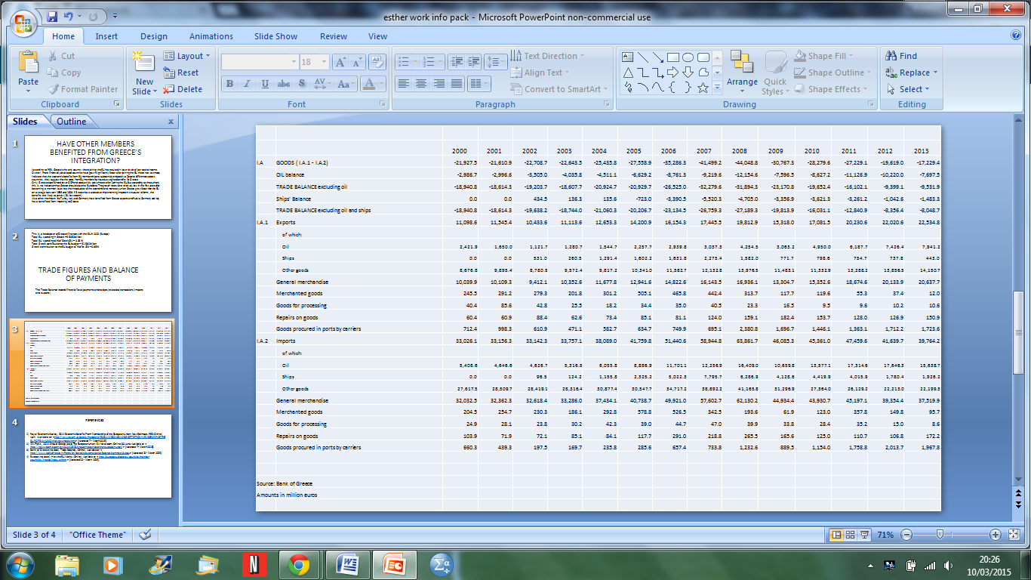
The Trade Balance records financial flows (payments and receipts) related to transactions (imports and exports).

We can conclude saying that other EU members have benefitted from Greece joining the EU however, the same cannot be said for Greece.
References for final two sub-sections:
Royal Economic Society, 2014. Economic Benefits From Membership of the European Union: New Estimates. RES (Online) April. Available at: < http://www.res.org.uk/details/mediabrief/6052141/ECONOMIC-BENEFITS-FROM-MEMBERSHIP-OF-THE-EUROPEAN-UNION-New-estimates.html > [Accessed 7th March 2015].
IZA Press, 2014. Should Greece Leave The European Union. IZA Newsroom (Online) 30 June. Available at: < http://newsroom.iza.org/en/2014/06/30/should-greece-leave-the-european-union/ > [Accessed 7th March 2015].
Bank of Greece (no date). Trade Balance. (Online). Available at: < http://www.bankofgreece.gr/Pages/en/Statistics/externalsector/balance/commercial.aspx > [Accessed 10th March 2015].
Europa (no date). How the EU Works. (Online). Available at: < http://europa.eu/about-eu/countries/member-countries/greece/index_en.htm > [Accessed 10th March 2015].
WORD COUNT: 1182

Nauro F. Campos, Fabrizio Coricelli, Luigi Moretti, 2014. How much do countries benefit from membership in the European Union? [Online] Available at: http://www.voxeu.org/article/how-poorer-nations-benefit-eu-membership [Accessed 09/03/2015]
Athanasios Vamvakidis, 2003. The convergence experience of the Greek economy in the EU: lessons for EU accession countries [Online] Available at: https://www.nbp.pl/konferencje/radisson/Mowcy/vamvakidis/vamvakidis_paper.pdf
European Commission (2015) Financial Assistance to Greece, Policy and surveillance, Economic and Financial Affairs (http://ec.europa.eu/economy_finance/assistance_eu_ms/greek_loan_facility/index_en.htm) LAST ACCESSED: 07/02/2015.
Ibid.
Feldstein, Martin (2010) Let Greece take a Eurozone 'Holiday', Financial Times, Belfer Center for Science for Science and International Affairs (http://belfercenter.hks.harvard.edu/publication/19932/let_greece_take_a_eurozone_holiday.html) LAST ACCESSED: 08/03/2015.

